Technical Design Report: Extended Multi-Cycle MIPS Processor:
Note: this report was initially generated by ai, by collecting and organizing my code comments, which was later regulated and revised by myself.

Definitions:
A set of predefined special codes(opcodes, func codes, state codes(for fsm)) to maintain classic Verilog compatibility and clean hardware synthesis.
`OP_RTYPE6'b000000
R-Type - Base register-to-register arithmetic/logical class.

`OP_ADDI6'b001000
I-Type - Add Immediate (signed execution).

`OP_LW6'b100011
I-Type - Load Word from Data Memory into Register File.

`OP_SW6'b101011
I-Type
Store Word from Register File into Data Memory.

`OP_BEQ6'b000100
I-Type
Branch on Equal (PC-relative conditional jump).

`OP_J6'b000010
J-Type
Jump to Absolute Unconditional Address.

Control unit:
Takes opcode and a few control signals(from memory) and evaluates all the control signals.
Control unit is a finite state machine and regarding it's previous state and control signals it decides which state to go and what signals to create(signals are indicated by state of the machine)

Step 1: Instruction Acquisition Cycle Block
- ST_FETCH: Asserts mem_read = 1 to initiate a read request. If a cache line hit occurs (cache_hit == 1), the internal state updates the hardware program counter by staging PC = PC + 4 (alu_srcA = 2'b00, alu_srcB = 2'b01, alu_control = 3'b000, pc_source = 2'b00), latches the fetched contents into the instruction storage register (ir_write = 1), commits the value to the PC memory block (pc_write = 1), and transitions smoothly into ST_DECODE.
- ST_CACHE_MISS: Entered if a cache line lookup fails. The block drops into a hardware hold phase, raising cache_stall = 1 to alert the processor wrapper, maintaining mem_read = 1 and enforcing i_or_d = 0 to hold the address stable at the PC pointer boundary until mem_ready signals completion.

Step 2: Operand Extraction & Pre-Calculation Phase
- ST_DECODE: Extracts core register designations.
Optimistic Branch Target Pre-Calculation: During this cycle, the processor reads the values from the integer register file while the ALU is idle. The ALU calculates a potential branch target address ahead of time assuming the current instruction may be a branch (alu_srcA = 2'b00, alu_srcB = 2'b11, alu_control = 3'b000). This pre-calculated address is captured inside the ALUOut register. If the instruction is later identified as a non-branch instruction, this computed target address is ignored without overhead ("win-win").

Step 3: Execution Paths per Instruction Classification
- Arithmetic R-Type & Immediates (ST_EXEC_R --> ST_ALU_WB):
  - ST_EXEC_R: Drives the inputs through the ALU core using register bounds (alu_srcA = 2'b01, alu_srcB = 2'b00). For immediate assignments (ADDI), the multiplexer switches to route sign-extended immediate fields (alu_srcB = 2'b10). Opcode and funct signatures map corresponding controls into the alu_control line.
  - ST_ALU_WB: Commits the computed result value back into the general register arrays (reg_write = 1). The write address target shifts depending on execution type (reg_dst = 00 for ADDI to write to rt; 01 for R-Type to write to rd).
• Memory Referencing Instructions (ST_MEM_ADR ST_MEM_RD/ST_MEM_WR ST_MEM_WB):
- ST_MEM_ADR: Combines base register rs with the sign-extended offset field to generate a physical memory reference address (Address = RegA + SignExtend(imm)).
- ST_MEM_RD: Used for LW operations. Sets i_or_d = 1 to drive the address line from ALUOut, raising mem_read = 1 to read from the memory data space. The FSM holds at this state until mem_ready is pulled high.
- ST_MEM_WB: Completes the data load loop by driving the register file write port from the buffered MDR register space (reg_write = 1, reg_dst = 2'b00).
- ST_MEM_WR: Used for SW operations. Sets i_or_d = 1 to drive the address line from ALUOut and routes the buffered data register RegB onto the memory write bus (mem_write = 1). It stalls execution until mem_ready validates the write transaction.
• Control Flow Operations (ST_BEQ_EX / ST_J_EX):
- ST_BEQ_EX: Implements a conditional branch check by executing a subtraction between the two buffered registers (alu_srcA = 2'b01, alu_srcB = 2'b00, alu_control = 3'b001). It asserts pc_write_cond = 1 and switches the PC input multiplexer to track the branch address pre-calculated during decode (pc_source = 2'b01). If the ALU zero flag is raised (alu_zero == 1), the branch target updates the PC; otherwise, the incremented $PC+4$ address remains unchanged.
- ST_J_EX: Handles absolute jump operations. It forces an immediate update to the program counter (pc_write = 1, pc_source = 2'b10), concatenating the upper bits of the current PC with the shifted target field embedded within the instruction:
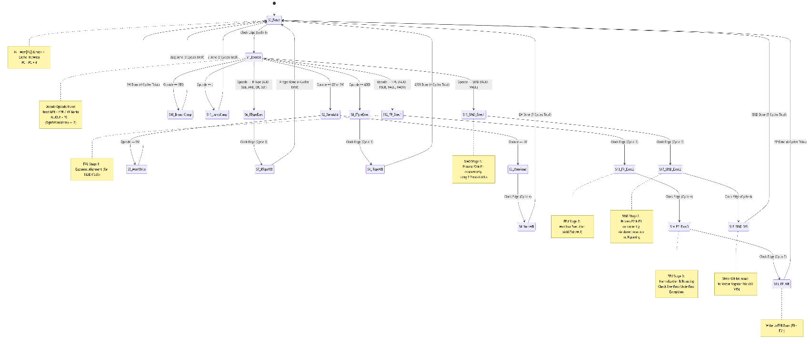
Finite State machine diagram

Wrapper:
Inputs:
mem_ready done fetch block from memory element
mem_block_in, input (rom) 4 words(for cache)
mem_data_in actuall data read from memory(like lw)
mem_addr, Tells the external memory where we want to read or write
mem_write_data, the data we wanna write, obviously
mem_global_write tells memory whether we wanna perform read or write
IR; // instruction register(IF)
MDR; // mem/wb register

pc_write write an address in pc - pc_write => active when condition instruction(beq)
i_or_d i/d: 0: address goes from pc(fetch) 1: address goes from alu(lw/sw)
ir/w => write in instruction register - reg_write => write in registers bank

2.1 Multi-Cycle Inter-Stage Boundary Registers
In a multi-cycle architecture, physical execution units (such as the ALU and Memory Interface) are shared across different operation phases. To prevent newly decoded instruction signals or transient execution stages from overwriting operands currently in flight, explicit non-architectural boundary buffers latch data at the conclusion of specific clock edges:
- Instruction Register (IR): Latches raw instruction data fetched from the L1 cache infrastructure. Controlled strictly by the state-driven ir_write signal combined with a valid cache_hit flag to preserve current state context during cache line misses.
- Memory Data Register (MDR): Captures incoming data read from the external memory bus during the data-read segment of a LW instruction sequence. This prevents register data corruptions prior to the final writeback cycle.
- Registers RegA and RegB: Captures stable outputs from the Integer Register File read ports during the decode sequence (ST_DECODE). Buffering these source elements guarantees operand continuity during consecutive execution cycles where register decode select controls fluctuate.
- ALU Output Buffer (ALUOut): Holds the computed output vector generated by the arithmetic logic unit. To maintain system stability during long-latency data memory transactions, updates to ALUOut are selectively gated:

always @(posedge clk) begin
if (!((mem_read || mem_write) && !mem_ready)) begin
ALUOut <= alu_result;
- This conditional assignment ensures that if the controller is stalling for an external memory device to complete a read or write operation, the valid target address or arithmetic vector stored in ALUOut is protected against being owerwritten

2.2 Datapath Routing Multiplexers
The execution path alters source inputs dynamically based on the current FSM execution step using a collection of multiplexing routing networks:
- Integer Register Destination Mux: Selects the target register address within the register file write port.
  - reg_dst == 2'b01: Selects rd (IR[15:11]) for standard R-type target updates.
  - reg_dst == 2'b00: Selects rt (IR[20:16]) for immediate ADDI operations or memory-load LW instructions.
- ALU Operational Source A Mux: Establishes the left operand boundary feeding the main integer ALU block.
  - 2'b00: Routes the current PC register value (used during instruction-fetch counter progression or branch offset base assembly).
  - 2'b01: Routes the buffered RegA operand extracted from the register bank.
- ALU Operational Source B Mux: Establishes the right operand boundary feeding the main integer ALU block.
  - 2'b00: Routes the buffered RegB register operand.
  - 2'b01: Connects a hardwired 32-bit constant value of 4 (dedicated for linear PC increment sequences).
  - 2'b10: Extracts the lower 16 bits of the Instruction Register (imm) and processes a full 32-bit arithmetic sign-extension to handle offsets for LW, SW, and ADDI operations.
  - 2'b11: Generates a specialized branch calculation operand by sign-extending the 16-bit immediate field and shifting it left by two positions (imm 2) to align with 32-bit MIPS word instruction spaces.

$$\text{mem_addr}=\left\{\begin{matrix}\text{ALUOut}, & \text{if }i_or_d=1 \left(\text{Data Space Operations}\right) \\ \text{PC}, & \text{if }i_or_d=0 \left(\text{Instruction Fetch Operations}\right)\end{matrix}\right.$$
Global strobes (mem_global_read, mem_global_write) are directly mapped to internal control outputs (mem_read, mem_write), allowing the host environment testbench or memory manager to observe core state intent instantaneously.

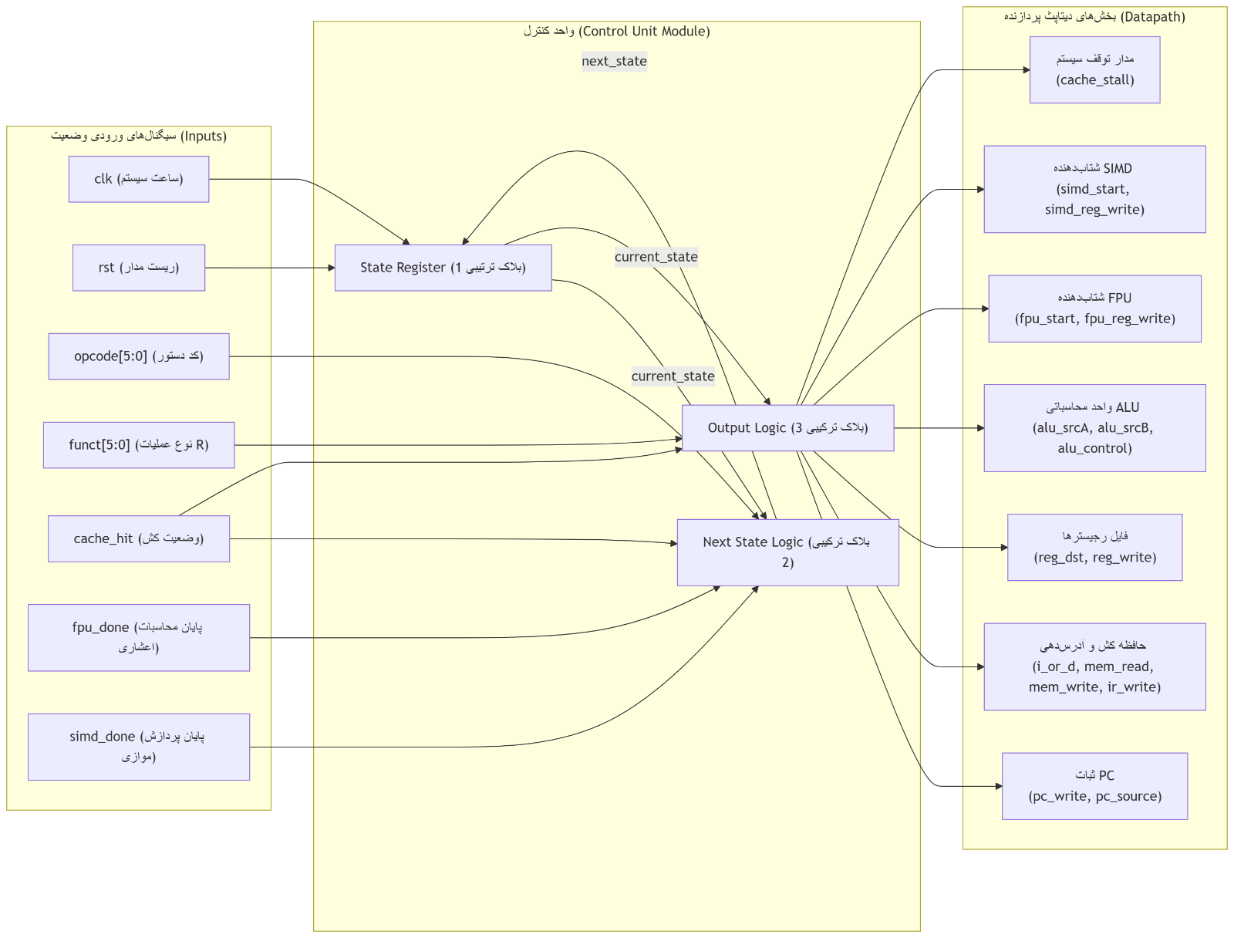

General Datapath
Todo: update datapath

L1 Instruction Cache Memory:
$$\text{Address Block Allocation: }\underset{\text{Tag Field (22 bits)}}{\underbrace{\text{addr}}} \underset{\text{Index Select (6 bits)}}{\underbrace{\text{addr}\text{[9:4]}}} \underset{\text{Word Select (2 bits)}}{\underbrace{\text{addr}\text{[3:2]}}} \underset{\text{Byte Offset (Ignored due to Word Alignment)}}{\underbrace{\text{addr}\text{[1:0]}}}$$
• Index Select (addr[9:4]): Formulates a 6-bit lookup key capable of addressing exactly $2^6 = 64$ independent cache lines.
• Tag Field (addr[31:10]): Contains the upper 22 bits of the structural address, representing the unique high-order identification signature of the memory block currently mapped to that specific index row.
• Word Select (addr[3:2]): Maps the 4 internal 32-bit storage arrays within a selected 16-byte block line, isolating the target instruction to be delivered to the processor core.

The cache hardware maintains three independent internal register file arrays to organize storage data:
reg valid [0:63]; // 1 bit Valid indicator array per row
reg [21:0] tags [0:63]; // 22 bit Address Tag tracker array per row
reg [31:0] data_store [0:63][0:3]; // 64 rows containing 4 x 32-bit memory blocks

(Hit / Miss Assessment):
The cache evaluates incoming requests combinationally to maximize throughput. If the selected line is validated and the stored tracking tag exactly matches the requesting address tag, a cache hit is registered:

When an instruction block is missing from the cache (cache_miss_req == 1), the system core stalls, and an external memory cycle is initiated. Once the memory interface completes the transfer of a 128-bit block and asserts mem_ready, the cache updates the indexed row on the next positive clock edge

RegisterFile_Int:
The register storage block contains 32 independent general-purpose 32-bit registers. It supports two combinational read operations and one synchronous write operation per cycle

ALU_int:
The ALU computes arithmetic or logical results combinationally based on the 3-bit alu_control input signal issued by the main controller.
Signed Less-Than Comparison Implementation
Standard Verilog relational operators (<, >) process inputs as unsigned vectors by default. To implement the MIPS SLT instruction properly, operands must be evaluated as signed values. The calculation block uses the $signed system function to cast inputs explicitly, ensuring negative integers are compared correctly

Test:
Memory Word Index | Assembly Instruction | Hexadecimal Representation | Target Operational Verification Metric
Word 0 | ADDI $1, $0, 10 | 32'h2001000A | Verifies immediate sign extension and positive integer assignment.
Word 1 | ADDI $2, $0, -5 | 32'h2002FFFB | Validates sign extension behavior with negative immediate operands.
Word 2 | ADD $3, $1, $2 | 32'h00221820 | Asserts correct R-type integer addition (10 + (-5) = 5).
Word 3 | SUB $4, $1, $3 | 32'h00232022 | Asserts correct R-type integer subtraction (10 - 5 = $).
Word 4 | AND $5, $1, $3 | 32'h00232824 | Validates bitwise logical AND operation (10 AND 5 = 0).
Word 5 | OR $6, $1, $3 | 32'h00233025 | Validates bitwise logical OR operation (10 OR 5 = 15).
Word 6 | SLT $7, $2, $1 | 32'h0041382A | Confirms $signed comparison correctness (evaluates -5 < 10 1).
Word 7 | SW $3, 100($0) | 32'hAC030064 | Validates Data Memory Store Word operation with simulated 2-cycle latency.
Word 8 | LW $8, 100($0) | 32'h8C080064 | Validates Data Memory Load Word operation into separate destination target register.
Word 9 | BEQ $3, $8, 1 | 32'h10680001 | Evaluates condition branch matching (5 == 5). Confirms PC skips Word 10.
Word 10 | ADDI $9, $0, 99 | 32'h20090063 | Dead Code Target: Used to verify that the branch logic does not execute this slot.
Word 11 | J 0 | 32'h08000000 | Forces program pointer jump to Word 0 to verify L1 Cache Loop Hit Rates.

